
- Home
- About Us
- Products & Services
- How We Work
- Contact Us
- Download

Request for Quotation
Get Demo




Managed Services
We are responsible for maintaining and monitoring the IT systems, networks, and software of the organization, ensuring that they are running efficiently and securely. Managed IT services typically include tasks such as software updates, network security management, data backup and recovery, and helpdesk support for end-users.
By choosing us your organizations can focus on their core business activities, while the MSP takes care of the technology infrastructure, providing a cost-effective and efficient solution to IT management.

Softwares we offer

PERSONALIZED SERVICES
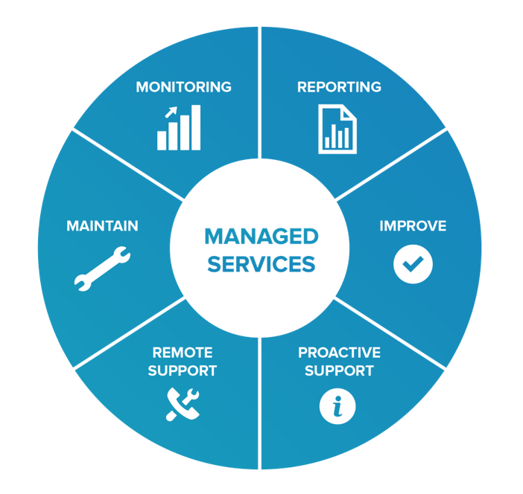
Pakiza Technovation Limited wants to take the opportunity to utilize its experts’ technical team to design, deploy and manage customer’s IT infrastructure in a professional way as agreed upon in a Service Level Agreement (SLA).
- Design , Implementation and integration
- Network, Security, Mobility, Compute, Storage

MANAGED IT SERVICE
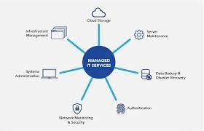
Managed IT services that are coupled with a Network Operations Center to proactively monitor systems, resolve issues and perform work with a level of expertise and efficiency unparalleled to other solutions.
- Managed IT Service..
- Hardware AMC
- IT Consultancy

BREAK & FIX
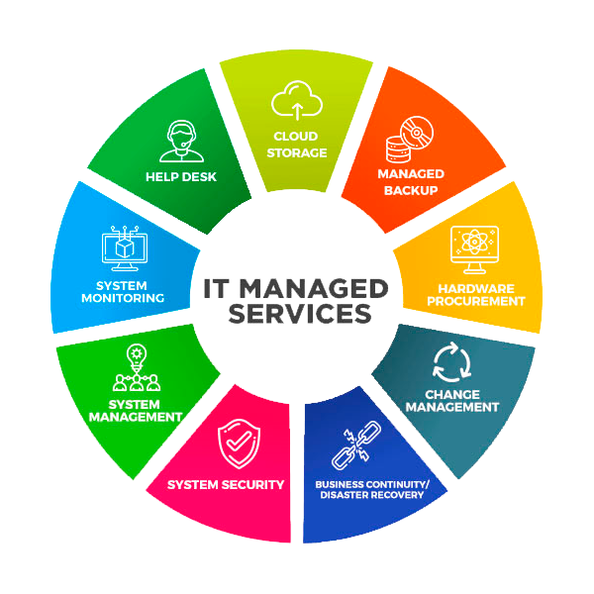
Although it’s an older style for delivering IT services and repairs to organizations, PTVL wants to fulfill the needs of customer. PTVL wants to do spare part replacement and circuit level repairing to run systems.
- Upgrade system
- Spare Part Replacement
- Circuit Level Repairing

HELP DESK

If you drive a small company and don’t want to spend much money on skilled IT resource. Pakiza Technovation Limited offers Help Desk service for you. It is also a part of managed IT service offering that provides information and technical support to your end user.
- Phone Support
- Remote Support

RESOURCE SHARING

An enterprise solution for storing, transmitting, creating, and using data through computing devices, networks and telecommunications.
- Design , Implementation and integration.e
- Network & Security, Mobility, Compute, Storage and Virtualization Migration.



With a mission to deliver Excellence, through Innovation in designing solutions, implementing those in an innovative way using the right technologies. Pakiza Technovation Limited is the newest concern of renowned Pakiza Group, the standard of excellence in all its business sectors. Pakiza Technovation Limited always love to optimize, not to be lowest price, its solution to meet its client’s requirement & thus ensure value for money.

Address
Head office : House# 97, Road# 11/A,
Dhanmondi, Dhaka-1209, Bangladesh
+880 9612 811 111
info@pakizatvl.com
Registered office: Khordo Nowpara,Rasulpur Narsingdi (Sadar), Narsingdi-1600, Bangladesh

Get Connected

App privacy and policy


© 2023 Pakiza Technovation Limited

